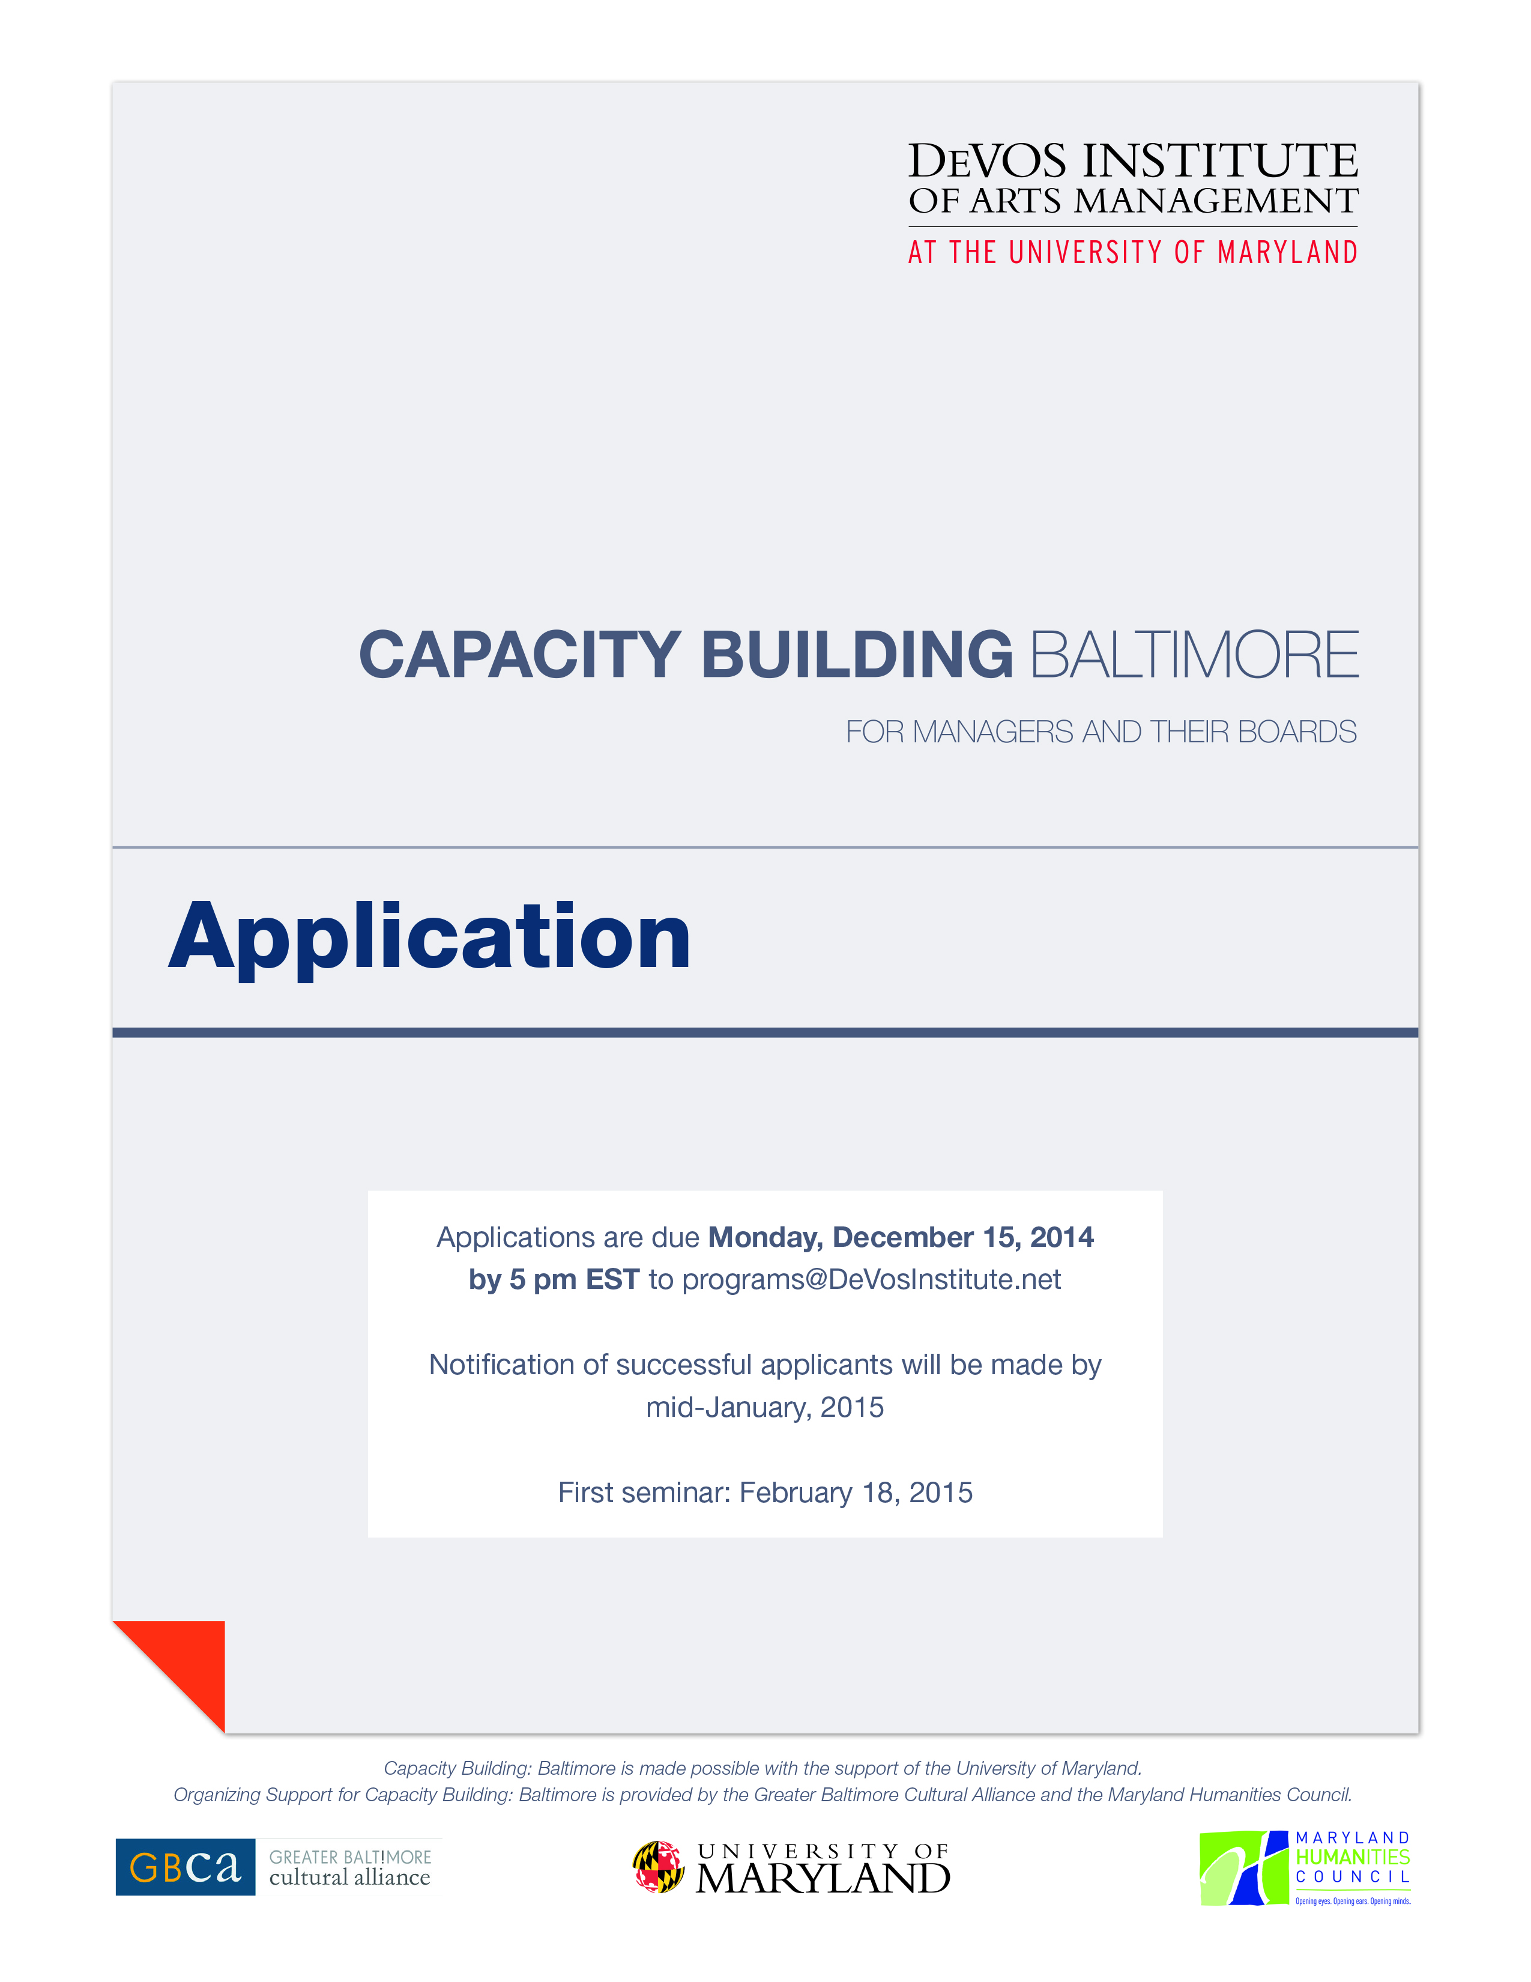
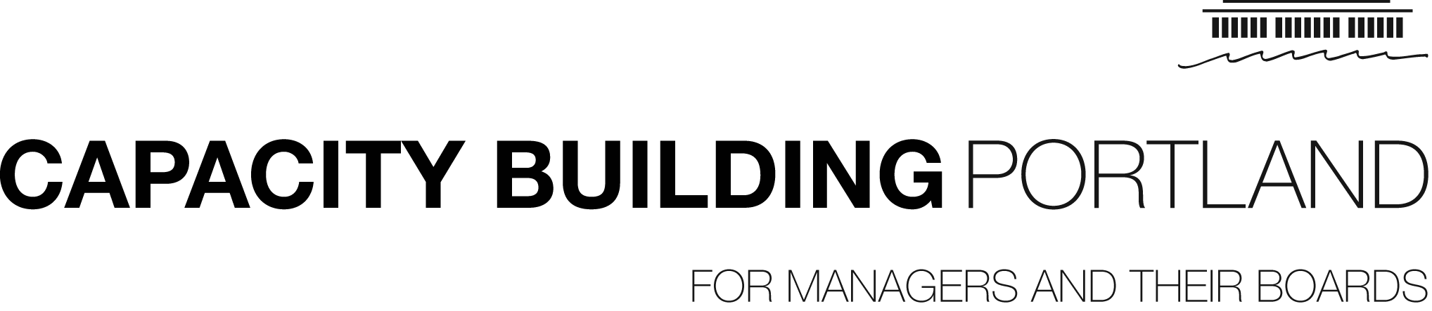
Contact Information
Applications are due Sunday, March 16, 2014 by 5:00 pm PST to capacitybuilding@kennedy-center.org

Notification of selected participants will be
made at the end of March.

First seminar: Monday, April 28, 2014
Application

Organization Name: Click here to enter text.
Address: Click here to enter text.
Phone: Click here to enter text.
Website: Click here to enter text.

Executive Director: Click here to enter text.
Email: Click here to enter text.
Phone: Click here to enter text.

Board Chair: Click here to enter text.
Email: Click here to enter text.
Phone: Click here to enter text.

Please list the names of those who, along with the Executive Director, should be
included on all program correspondence.

Primary Program Contact (if different from Executive Director): Click here to enter text.
Email: Click here to enter text.
Phone: Click here to enter text.

Program Contact: Click here to enter text.
Email: Click here to enter text.
Phone: Click here to enter text.

Organization Information

Mission Statement:
Click here to enter text.

Summary of Programmatic Offerings and Disciplines Served:
Click here to enter text.

Please enter the following financial information:
 | FY 2013 | FY 2014 | FY 2015 (Projected)
Earned Revenue | Click here to enter text. | Click here to enter text. | Click here to enter text.
Contributed Revenue | Click here to enter text. | Click here to enter text. | Click here to enter text.
Total Expenses | Click here to enter text. | Click here to enter text. | Click here to enter text.

Please attach your financial plan or pro forma budget.

Number of Full-Time Staff Members: Click here to enter text.
Number of Part-Time Staff Members: Click here to enter text.

Please attach a detailed staff list.

Number of Board Members: Click here to enter text.

Please attach a list of board members and affiliation.

Does your organization have a strategic plan? ☐Yes ☐No

If yes, please attach a copy of your strategic plan.

Work Path

Please specify your organization’s one-year and two-year objectives within the areas of strategic planning, individual giving, and board development. Please also identify your organization’s chosen work path area of focus (“Area 4” below) and specify your objectives in this area.

Area 1 — Strategic Planning:
Objectives – Year 1
Click here to enter text.

Objectives – Year 2
Click here to enter text.

Area 2 — Individual Giving:
Objectives – Year 1
Click here to enter text.

Objectives – Year 2
Click here to enter text.

Area 3 — Board Development:
Objectives – Year 1
Click here to enter text.

Objectives – Year 2
Click here to enter text.

Area 4 — (please specify): Click here to enter text.
Objectives – Year 1
Click here to enter text.

Objectives – Year 2
Click here to enter text.
Proposal

Please submit a brief statement addressing how your organization will use the time and resources allocated in this program.

Click here to enter text.

Please submit a brief statement addressing your organization’s impending opportunity or need that requires capacity building support.

Click here to enter text.

Please explain your chosen work path area of focus (“Area 4”) and detail why additional support is needed in this area.

Click here to enter text.

The Cycle Audit Contact Information

Please list the name and contact information for three organizational representatives who will complete the DeVos Institute’s Cycle Audit. At least three representatives from your organization—including one board member—will be asked to complete the Audit independently. Because the survey is administered electronically, email addresses are required. Please note the Cycle Audit will take approximately 30 minutes to complete.

Executive Representative: Click here to enter text.
Email: Click here to enter text.
Phone: Click here to enter text.

Artistic Representative: Click here to enter text.
Email: Click here to enter text.
Phone: Click here to enter text.

Board Representative: Click here to enter text.
Email: Click here to enter text.
Phone: Click here to enter text.

Additional Staff or Board (Optional): Click here to enter text.
Email: Click here to enter text.
Phone: Click here to enter text.

Additional Staff or Board (Optional): Click here to enter text.
Email: Click here to enter text.
Phone: Click here to enter text.

Additional Staff or Board (Optional): Click here to enter text.
Email: Click here to enter text.
Phone: Click here to enter text.
Group Seminar 1 – February 18, 2015

Please list the name and contact information for three organizational representatives who will attend the first group seminar in Baltimore. Participation by executive, artistic, and board representatives is expected. (At this time we can only register three participants per organization. If space becomes available, organizations will be invited to bring additional participants.)

Executive Representative: Click here to enter text.
Title: Click here to enter text.
Email: Click here to enter text.
Phone: Click here to enter text. Ext: Click here to enter text.

Artistic Representative: Click here to enter text.
Title: Click here to enter text.
Email: Click here to enter text.
Phone: Click here to enter text. Ext: Click here to enter text.

Board Representative: Click here to enter text.
Title: Click here to enter text.
Email: Click here to enter text.
Phone: Click here to enter text. Ext: Click here to enter text.

Terms of Agreement

If invited to participate in this program, we will commit to the following:

- Staff will communicate regularly with our assigned Institute advisor;

- Staff and board representatives will participate in phone conferences and in-person meetings with our Institute advisor and Institute leadership;

- Staff and board representatives will submit the DeVos Institute’s Cycle Audit, completed by a minimum of three organization representatives, including executive, artistic, and board leadership each year of the program;

- Staff will communicate regularly with Institute staff and submit reports regarding progress on our defined benchmarks;

- Staff and board representatives will attend all five group seminars;

- Staff and board representatives will participate in online master classes.

Accepted and Agreed:

Name (Executive Director): Click here to enter text. Date: Click here to enter text.

Name (Board Chair): Click here to enter text. Date: Click here to enter text.

